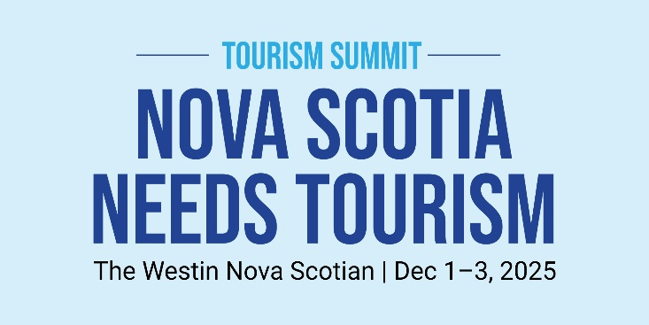

MEDIA RELEASE
For Immediate Distribution
TOURISM INDUSTRY HOSTS PROVINCIAL SUMMIT
Halifax, NS (November 28, 2025) – The Tourism Industry Association of Nova Scotia (TIANS) will welcome hundreds of tourism businesses from across the province during the 2025 Tourism Summit taking place from December 1st through the 3rd at The Westin Nova Scotian.
Under the theme of Nova Scotia Needs Tourism, the Summit features an agenda built around the recently released Strategic Plan for Tourism. Along with captivating keynote speakers and educational sessions, there will be remarks from the Honourable Dave Ritcey, Minister of Communities, Culture, Tourism and Heritage during a Luncheon event on Tuesday, December 2nd.
“This is a critical time for the tourism industry in Nova Scotia as we begin to collectively work to advance the goals outlined in the Tourism Sector Strategic Plan, says Kevin Toth, TIANS Chair. “Tourism is a $3.5-billion industry in Nova Scotia with significant opportunities for growth. The Summit provides an opportunity to explore innovative approaches to tourism development, global best practices and new partnership opportunities.”

“Nova Scotia Needs Tourism,” says Darlene Grant Fiander, TIANS President. “Beyond the immediate economic impact, tourism enhances the social, cultural and environmental health of the province. Grant Fiander added, “The 2025 Tourism Summit program includes sessions that reflect industry challenges such as seasonality, labour, access and digital innovation.”

Working with partner associations and stakeholders, TIANS is committed to representing the best interests of the industry, enhancing and supporting the development of a competitive business environment for Nova Scotia’s most promising economic sector. For additional details, visit: www.conferenceontourism.com
For a Media Pass, or to schedule an interview during the 2025 Tourism Summit, contact: lisa@tourism.ca
30 -
Media Contact:
Ms. Lisa Dahr, Director, Industry Relations & Professional Development
Tourism Industry Association of Nova Scotia
T: (902) 880-4088| E: lisa@tourism.ca www.tians.org

