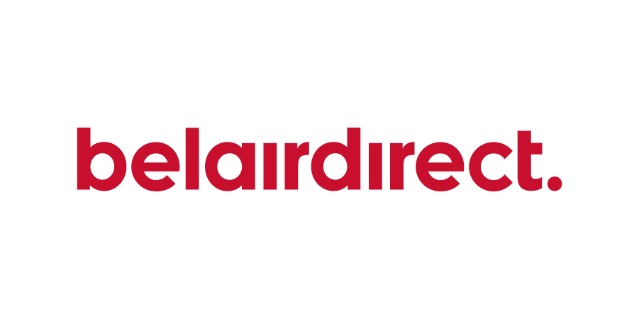

Simplify your insurance with exclusive offers from belairdirect

Enjoy exclusive savings on car, home, condo and travel insurance through our official partner, belairdirect. You'll benefit from tailored coverage, including enhanced home insurance with the Affinity Plus endorsement and great car insurance add-ons. Plus, easily manage your car and home insurance with belairdirect's digital tools.

Travel with peace of mind thanks to annual travel insurance that covers emergencies, trip disruptions, and more, all at exclusive group rates with no age or health restrictions¹. Choose from flexible payment options.

To get your car and home insurance price, visit: belairdirect.com/exclusive-savings

For your travel insurance price, visit belairdirect.com/travel or call 1 833 583.3643 and mention your group name.
It’s more than just a policy. When you get insurance through belairdirect, you’re also supporting TIANS.

Legal disclaimers
Eligibility requirements, limitations and exclusions may apply and/or may vary by province or territory. The information provided in this summary is for informational purposes only and should not be considered legal or insurance advice. Policy wordings prevail. © 2025 Belair Insurance Company Inc. All rights reserved.
Travel insurance products are underwritten by Belair Insurance Company Inc. and services are provided by belairdirect Agency Inc.
¹ This insurance may not cover claims related to medical conditions that are not stable, whether disclosed or not at time of policy purchase.

